PHOTOELECTRIC EFFECT
The process that occurs when light shines on a metal and photoelectrons are ejected off the surface of the metal.
SIGNIFICANCE OF THE PHOTOELECTRIC EFFECT
It establishes the quantum theory and it illustrates the particle nature of light.
INTERACTION BETWEEN LIGHT AND MATERIALS
When light strikes or any electromagnetic radiation strikes the surface of an object, light or the electromagnetic radiation can be absorbed, reflected, transmitted or any combination of these effects. Light is energy, and when it strikes a metal, this energy is transferred to the electrons in the atoms. The amount of energy that is transferred depends on the material. Since the energy levels in metals are close together, almost all frequencies of light can be absorbed, exciting electrons into higher available energy levels.
When the frequency of the light is different to the natural energies of the electrons in the atom material, the light passes through and is therefore transmitted. In non-metals such as insulators, energy gaps between conduction bands and the valence bands are very large. So for an electron to move into the empty energy level in the conduction band requires a lot of energy. When light is absorbed, the greatest transfer of energy takes place. When light is scattered, very little energy transfer takes place. The absorbed energy is converted into internal energy, making the object hot. If no light is reflected or transmitted, the object will appear black. The colour of an object is determined by the frequency of the light it transmits.
THRESHOLD FREQUENCY OR CUT –OFF FREQUENCY
Only light of sufficiently high frequency can eject electrons from a metal plate. This minimum frequency required to eject the photoelectrons off the surface of a metal is called threshold or cut off frequency (f_{o}).
Increasing the intensity of the ultraviolet light causes more electrons to be ejected per second.
From the equation, E = hf where E is the amount of energy in J, h is Planck’s constant = 6,63 x 10⁻³⁴ J•s and f is the frequency of the incoming light in Hz.
WORK FUNCTION (W_{o})
Energy is needed to remove an electron from a metal. For any metal, a minimum amount of energy, called the work function (W_{o}) is needed to remove an electron from the surface of a metal. The energy of the photon must be equal to or greater than the work function of the metal before electrons will be ejected.
The equation is:
W_{o} = hf_{o}
Where
W_{o} is work function in Joules (J),
h is Planck’s constant= 6,63 x 10⁻³⁴ J•s
f_{o} is the threshold frequency in Hertz (Hz).
The maximum kinetic energy of the ejected electrons can also be determined where
K_{max} = E – W_{o}
Thus, E = W_{o} + K_{max}
Where is the energy of the incoming light and can be determined from
E = hf and W_{o} is the work function of the metal and can be determined from W_{o} = hf_{o .}
The speed of the emitted electron or photoelectron can then be determined from K_{max} = ½mv² where m is the mass of the electron which is given on the Data Sheet.
Thus, the equation can now become:
hf = W_{o} + ½ mv²
Graphical Interpretation in Photoelectric Effect
- A change in the intensity of light does not affect the maximum kinetic energy. A graph of maximum kinetic energy against intensity is a simple horizontal line.
- A graph of maximum kinetic energy against frequency is a straight line with a positive gradient and a negative intercept on the y axis. The graph matches a relationship of the general form y = mx + c, where, in this case, y is the maximum kinetic energy and x is the frequency.
- The value of the gradient m is found by experiment to be 6.6 × 10^{–34} J s, and the value of the intercept when the metal is sodium is found to be –3.6 × 10^{–19}J.
- Thus for sodium: E_{k max} = 6.6 × 10^{–34}f – 3.6 × 10^{–19}J.
- The graph of maximum kinetic energy against frequency passes through the x axis at the lowest frequency at which the emission of electrons can take place. This frequency is called threshold frequency.

DUAL NATURE OF LIGHT
Light thus undergoes refraction and diffraction and this demonstrates its wave nature.
The photoelectric effect demonstrates the particle nature of light.
EMISSION AND ABSORPTION SPECTRA
There are three different types of spectra:
- Continuous emission spectra
- Line emission spectrum
- Line absorption spectrum

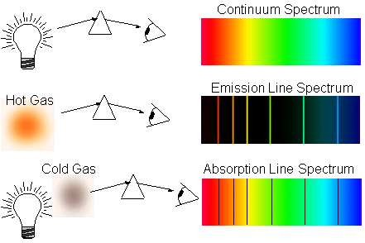

An electron may absorb energy and it can now move up one or more energy levels inside the atom. The electron is said to be “excited”. When this electron returns to its ground state, a photon of energy is released. If the involved atoms in the discharge tube emit photons having only certain specific energies, it implies that the internal energy of the atom will only increase or decrease in steps, or that the internal energy of an atom is distinctive by certain discreet energy levels. If an electrons gains internal energy, the electron jumps between energy levels. When an electron loses internal energy, it emits energy as a photon that contains energy.
E = E₂ – E₁
Where, E is the energy of the photon E₂ – E₁ is the total internal energy between two energy levels which energy jump took place.
An atomic absorption spectrum is formed when certain frequencies of electro - magnetic radiation that passes through a medium e.g. a cold gas is absorbed.
An atomic emission spectrum is formed when certain frequencies of electromagnetic radiation are emitted due to an atom’s electrons making a transition from a high-energy state to a lower energy state.
QUESTION 1 (DBE November 2015)
In an experiment to demonstrate the photoelectric effect, light of different wavelengths was shone onto a metal surface of a photoelectric cell. The maximum kinetic energy of the emitted electrons was determined for the various wavelengths and recorded in the table below.
1.1. What is meant by the term photoelectric effect? (2)
1.2. Draw a graph of E_{k(max)}(y-axis) versus 1/λ (x-axis) (3)
1.3. USE THE GRAPH to determine:
1.3.1 The threshold frequency of the metal in the photoelectric cell. (4)
1.3.2 Planck's constant. (4)
QUESTION 2 (ieb Hilton College Trial 2012)
A metal plate is illuminated with an ultra violet radiation of frequency 1.67×10¹⁵ Hz. The maximum kinetic energy of the liberated electrons is 3.0×10⁻¹⁹ J.
2.1 Calculate the energy of one photon. (3)
2.2 Calculate the work function of the metal. What does this number
represent? (4)
2.3 The radiation is maintained at the same frequency, but the intensity is doubled. State and explain what changes, if any, occur to the number of electrons released per second and the maximum kinetic energy of these electrons. (4)

QUESTION 3 (ieb November 2012)
PHOTOELECTRIC EFFECT EXPERIMENT
Electromagnetic radiation of varying frequency is shone on the sodium metal cathode of a photocell. The maximum kinetic energy of the photoelectrons emitted is recorded.
Table to show how the maximum kinetic energy (E_{k}) of a photoelectron emitted from sodium metal varies with the frequency (f) of the electromagnetic radiation.
3.1 Plot a graph of maximum kinetic energy versus frequency as represented by these results for sodium metal. Use the GRAPH PAPER PROVIDED on your Answer Sheet. The scale on the y-axis has been marked for you. You must fill in your own scale for the x-axis which must start at ZERO. (6)
3.2. Define threshold frequency. (2)
3.3. Read off the threshold frequency for sodium metal from the graph. (2)
3.4. If the maximum kinetic energy of the photoelectrons emitted is 2,0 eV then determine:
3.4.1. The frequency of the radiation incident on the sodium metal cathode. (1)
3.4.2. The wavelength of the radiation incident on the sodium metal cathode. (3)
3.4.3. The energy of the radiation incident on the sodium metal cathode (in joules) (3)
3.5. State and explain how the graph would change (if at all) when the intensity of the light is increased for each of the frequencies used. (3)
3.6. The magnitude of the value given by the y-intercept is equal to the work function (W_{f}) of the metal.
3.6.1. Extend your graph backwards to cut the y-axis and hence state the work function of the metal (in eV). (1)
3.6.2. Convert your answer to Question 7.6.1 to joules. (1)
3.6.3. Use the photoelectric effect equation, E = W_{f} + ½ mv², to explain why the y-intercept is equal to the work function (W_{f}). (3)

QUESTION 4(Ieb November 2015)
4.1. An electroscope with a negatively charged zinc plate is shown below. The gold
leaf is deflected due to like charges repelling each other.

When visible light is shone on the plate, nothing is observed. When ultraviolet light is shone on the negatively charged electroscope, the gold leaf collapses.

4.1.1 Name the phenomenon described. (2)
4.1.2 Explain why visible light has no effect while the ultra-violet light collapses the
gold leaf. (3)
4.2. The work-function of caesium is 3,36 × 10⁻¹⁹ J.
4.2.1. Define work-function. (2)
4.2.2. Calculate the lowest frequency photon that can eject an electron from
caesium. (3)
4.2.3. Calculate the maximum kinetic energy of an electron ejected from caesium by
a photon of wavelength 400 nm. (4)

QUESTION 5 (ieb November 2015)
In an experiment, light of different wavelengths was shone onto a metal surface. The kinetic energy of the emitted electrons was determined and recorded in a table:
5.1. Plot a graph of 1/λ (x axis) against EK (y axis). (7)
5.2. The photoelectric equation is

Rearrange this equation into a straight line form (appropriate for your graph), and use your graph to determine
5.2.1. The work function, W₀ (2)
5.2.2. Planck’s constant, h (3)

QUESTION 6
6.1. The graph below shows the relationship between the kinetic energy of the ejected photoelectrons and the frequency of the incident radiation.
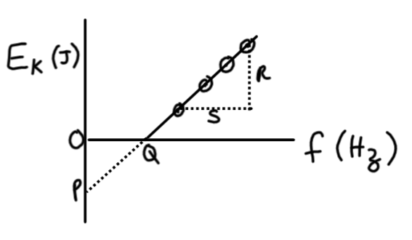

Which set correctly shows the information provided by P, Q, R and S?

 | $${\text{R}}/{\text{S}}$$ | P | Q
 | Planck’s constant, h | Threshold frequency, f₀ | Work function, W₀
B | Work function, W₀ | E_{K} of electrons when f = 0 | Threshold frequency, f₀
C | Threshold frequency, f₀ | Work function, W₀ | Planck’s constant, h
D | Planck’s constant, h | Negative of work function, -W₀ | Threshold frequency, f₀

